**Assignment 8.1:**

Copying dataset from local file system to hadoop file system



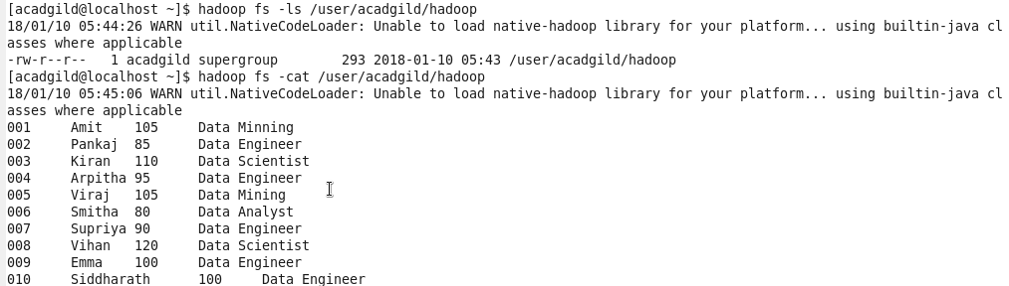

Creating hive table from a given dataset:

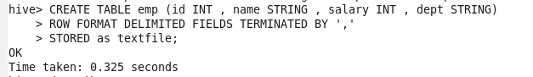

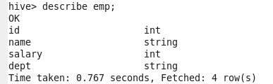

Loading data in to a hive table created:

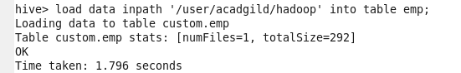

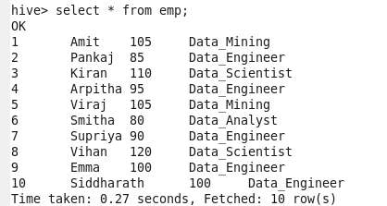

**Problem Statement1:**

Get a list of employees who receive a salary less than 100, compared to their immediate employee with higher salary in the same unit

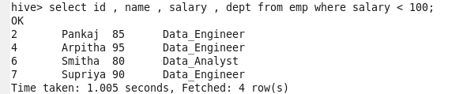

**Problem Statement2:**

List of all employees who draw higher salary than the average salary of that department

Select temp.salary > avg_salary , temp.dept

(select avg(salary) from emp)temp